The Whittacker progression for dozen and column bets
In our December 2002 update we have published a discussion about the Whittacker progression for even money bets.
Here is an adaptation of the Whittacker progression for dozen and column bets
( twelve number bets ).
If the Whittaker progression is applied to twelve number bets, the following starting sequence is used:
1. bet 1 unit
2. bet 1 unit
3. bet 2 units
If the first bet wins, profit: 2 units.
If the second bet wins, profit: 1 unit.
If the third bet wins, profit: 2 units.
In each of these cases the progression begins new with the sequence: 1 - 1 - 2!
If the first 3 bets are lost, the next bet is determined as follows:
with a negative balance between 4 to 9 units the balance is divided by 2,
with a negative balance between 10 to 21 units the balance is divided by 3,
with a negative balance between 22 to 100 units the balance is divided by 4,
With a negative balance over 100 units the balance is divided by 5.
If the result of the division is not a whole number, then this number is always rounded up.
The progression starts always with a bet size of 1 unit!

• Bet No. 1: 1 unit, in case of a win next bet 1 unit, in case of a loss:
• Bet No. 2: 1 unit, in case of a win next bet 1 unit, in case of a loss:
• Bet No. 3: 2 units, in case of a win next bet 1 unit, in case of a loss: 4 : 2 = 2
• Bet No. 4: 2 units, in case of a win next bet 1 unit, in case of a loss 6 : 2 = 3
• Bet No. 5: 3 units, in case of a win next bet 1 unit, in case of a loss 9 : 2 = 4.5 =5
• Bet No. 6: 5 units, in case of a win next bet 1 unit, in case of a loss 14 : 3 = 4.66 = 5
• Bet No. 7: 5 units, in case of a win next bet 4 : 2 = 2 units, in case of a loss 19 : 3 = 6.33 = 7
• Bet No. 8: and so fourth...
Example 1, from Table No.1, Spielbank Hamburg, 2003-04-03, Dozens (spin 1 - spin 40), betting selection: before last (we do not recommend this betting selection, it is solely to demonstrate the progression).
Highest bet size in this demo is 2 units.
Net result for the progression after 40 spins: + 13 units.
Net result for flat betting after 40 spins: + 4 units.
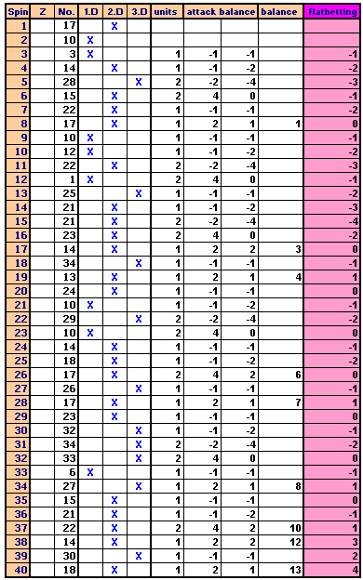
Example 2, from Table No.1, Spielbank Hamburg, 2003-04-05, Columns (spin 1 - spin 60), betting selection: last (we do not recommend this betting selection, it is solely to demonstrate the progression).
Highest bet size in this session is 14 units.
Net result for the progression after 60 spins: + 7 units.
Net result for flat betting after 60 spins: - 8 units.
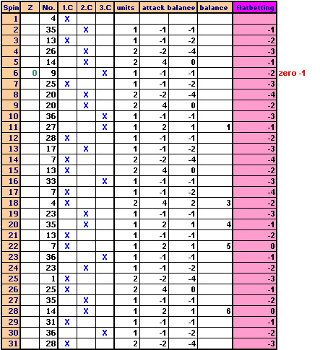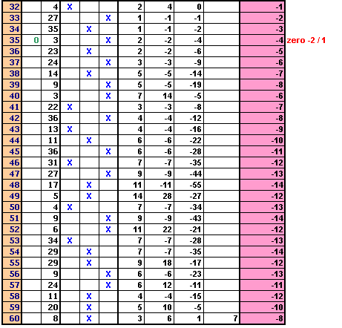
As you can see in example 2 we need only a couple of bets to recover after a bad spin run. However, this example is a good demonstration not to use the bet on last for twelve number bets.
If you lose a bet due to zero /double zero, repeat the bet. The amount lost due to the zero appearance has to be subtracted from the session balance.
The Whittaker progression should be used in no case without a good betting selection.
Both, the selection "bet on last" and "bet before last" are in no way good betting selections for 12 number bets. They, once again, they were only used to make the progression clear!

