TIER ET TOUT
Using a negative progression always carries the danger of a sudden loss of the capital either by very large bets, reaching the table maximum or due to the appearance of zero / double zero when placing large bets.
This danger does not exist using a winning progression: here the bets are raised utilizing the casino’s money. Only a very balanced win-loss sequence, making the capital gradually smaller, is dangerous. Winning progressions are also called "unlosable".
One form of a winning progression is the method "TIER ET TOUT"
(tier et tout, French: a part and the whole).
Tier et Tout is a money maneuver, which can be used with any betting selection.
Essentially Tiers-et-Tout works like this: we take a certain amount, from which we use 1/3 for the first bet. If this first bet is lost, we bet the rest, therefore 2/3 of the available amount. If we win with the first or the second bet, we increase the original amount about the profit and bet again, first 1/3 of the raised amount and if the first bet loses, we bet again the rest of 2/3.
Following is the best Tier et Tout we know:
- We start with 9 units using 3 units for the first bet and when this bet loses, we bet the remaining 6 units. If one of the 2 bets wins, we have now 9 + 3 units available.
- Now we bet 4 units and if this bet loses we bet 8 units.
A win on either bet leads to 12 + 4 = 16 units.
- Now we bet 5 units and in case of a loss 10 units.
If one bet wins we have a capital of 16 + 5 = 21 units.
- The next bet is 7, if the first bet is lost 14 units.
A win brings the capital to 21 + 7 = 28 units.
- The next bet is 9, resp. 18 units, bringing the capital to 28 + 9 = 37 units.
- Now we can bet 12 units and in case of a loss, we bet 24 units.
New capital is now 37 + 12 = 49 units.
- Next stage 15 / 30, capital : 49 + 15 = 64 units.
- Next stage 20 / 40, capital : 64 + 20 = 84 units.
- Next stage 25 / 50, capital : 84 + 25 = 109 units.
After stage 6, we take 4 units and after stage 7 we take another 5 units from the capital. Now we operate with the casino’s money.
From stage 9 we stay on bet sizes 25 / 50 until we have 2 consecutive losses.
Obviously this form of money management is quite interesting because the gains can come very fast as long as we do not encounter 2 consecutive losses. As mentioned before we can use TIER et TOUT in combination with any betting selection on the even money chances For ease of understanding we use in the following demonstration the bet on the last spin. We like to stress that we do not recommend betting on the last spins as a superior betting strategy, this is only for demonstration purposes.
The session below is from Spielbank Hamburg, Table No. 1, 2002-06-03.
Check HAMBURG SPINS JUNE 2002
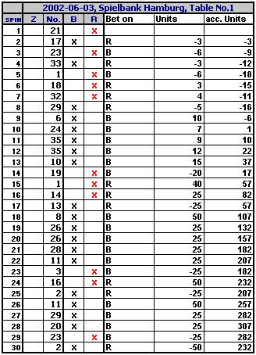
Although the first 4 bets are lost due to the single appearances, the session is terminated with a gain in excess of 200 units!

TIER et TOUT Part 2
In our June 2002 BASICS update we have published the original version
of the TIER et TOUT winning progression for even money bets.
Here is an adjusted or "stretched" type of TIER et TOUT to overcome double losses.
This variant is less risky compared to the original TIER et TOUT Parlay, so you will be able to continue more frequently and longer, without being out-stopped by two consecutive losses.
This is achieved by splitting the starting capital or "starting mass" into three different parts. Even after two consecutive losses a profit or a neutral balance will result due to this split.
Long winning runs, even with intermediate consecutive losses of two bets can continue in the most favorable case over more than 70 decisions, whereby it is possible to reach the table maximum.
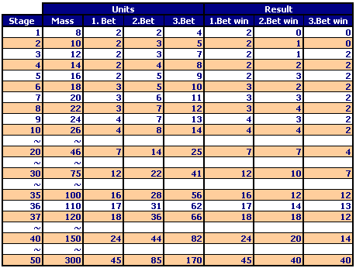
Our recommendation is to start with stage 2 (10 units starting mass) !
With the original TIER et TOUT progression the starting mass doubles after the fourth stage every two to three stages. The risk of unsuccessful attempts however, is rather high.
With the stretched TIER et TOUT version the starting mass grows only gradually in the initial stages, but often you will remain much longer in the run and achieve higher stages of the capitalization. Additional security comes from the "reserve units"! These are units which remain after the splitting.
This version of TIER et TOUT should be used in combination with a good bet selection.
Certainly you will need multiple "starting masses" for your game in order to overcome unsuccessful phases of your bet selection.

