D´ALEMBERT PROGRESSION - STRETCHED VERSION

( HENRY CHATEAU´S PROPOSAL )
The original d`Alembert progression for the even money chances follows an arithmetric row:
1 - 2 - 3 - 4 - 5 - 6 - 7 - etc.
It always starts with a base bet of 1 unit. After a loss the betsize in the next stage is raised 1 unit and after a win the betsize for the next stage is reduced by 1 unit.
Example 1:
For ease of demonstration we bet continuously on BLACK.
( We strongly advise not to use this kind of betselection )
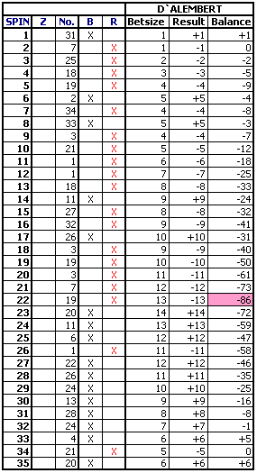
The dangers of this type of progression are strong deviations which sometimes require quite large bets for a return to the balance. In our 1. Example the highest downswing is minus 86 units, the largest bet is 14 units. The bankroll required must be very large.
Henry Chateau found a way to considerable reduce the risk of very large bets by increasing the betsize by fractions of 1/4, 1/5 and even 1/10 of the original unit.
But how might it be possible to raise a minimum wager of for example USD 5 by 1/10 ?
The solution for this problem are "indexed" bets:
1.1, 1.2, 1.3, 1.4, 1.5, 2.1, 2.2, 2.3, 2.4, 2.5, 3.1, 3.2 etc. pp.
We bet the following sequence of 1.1, 1.2, 1.3, 1.4 and 1.5 with 1 unit prior to raising the bet to 2 units. Then we play the sequence of 2.1, 2.2, 2.3, 2.4 and 2.5 with 2 units before we raise to 3 units etc.
The betsize is reduced in the same manner.
The index-numbers .1, .2, .3, .4 and .5 are only for bookkeeping.
Example 2:
Here, using the stretched D`Alembert, the highest down swing is 23 units and the largest bet is only 3 units! This is quite a difference in comparison to the original D`Alembert.
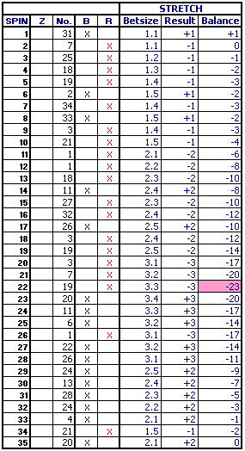
Below are both progressions combined for a direct comparison:
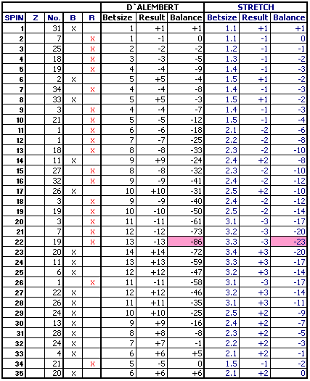
In connection with a good betselection the Stretched D`Alembert surely is a good choice for the even money player.

TRY FOR YOURSELF !

