PLUSCOUP PROGRESSION

( BOULE DE NEIGE )
The PLUSCOUP PROGRESSION is a winning or "up as you win" progression.
The first bet size is always 1 unit.
If this first bet wins, then the attack is terminated and again 1 unit is bet.
If the first bet loses, the bet size remains 1 unit up to the first win.
After the first hit with 1 unit the bet size is increased to 2 units.
As long as the balance is negative, after a win the bet size is increased by 1 unit.
This raise after a win is to be continued, until either a positive balance is achieved, or up to a specific relation between wins and losses.
Which of these two possibilities the user selects, depends on his personal preferences. One prefers to secure with small bankroll requirements a small win, the other one accepts a higher downswing if he can realize thereby a substantial win.
The PLUSCOUP PROGRESSION is a very shallow progression, with which the bet size rises only slowly.
In the following example on BLACK / RED we try to win 8 units.
For simplicity we bet only on RED:
Spielbank Hamburg, Table No.1, 2004-01-07
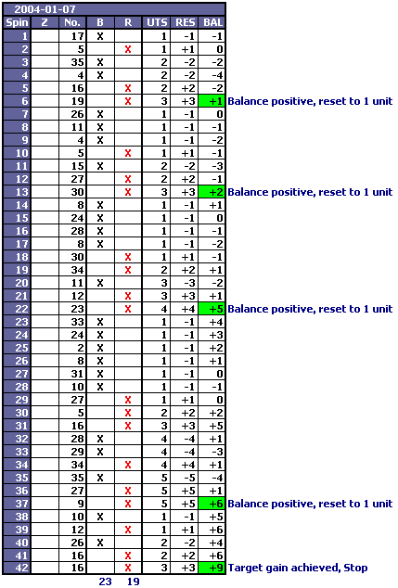
With a balance of +9 the session is terminated. In 42 spins Red loses 23 times and wins only 19 times. However the result is quite impressive. The cautious player could have reduced the last bet of 3 units to 2 units in order to achieve the target gain of 8 units, herewith protecting his bankroll. Disadvantage: the smaller bankroll requirement reduces the profits.
Even with larger tensions between losses and wins the PLUSCOUP PROGRESSION still leads to remarkable profits. The bankroll requirements are much lower than for example with the Whittacker or the Labouchere progressions.
The PLUSCOUP PROGRESSION seems to be the only one of the well-known progressions, especially in the case, in which only a few plus spins are missing, for reaching a positive balance, with by far the smallest bankroll requirements.
In combination with a good bet selection the PLUSCOUP PROGRESSION leads to very stable results.

TRY FOR YOURSELF !
TO BE CONTINUED !

