Whittacker progression for even money bets
The strategy of the Whittacker progression for even money bets is from principle somewhat similar to the Labouchere:
one win repays two losses.
While with the Labouchere the lowest and the highest bets of a loss-sequence are added and in case of a win are cancelled, Whittacker always adds the two last lost bets. This leads in most cases to a faster regain of the previous losses as with the Labouchere.
Compared with the Labouchere, the Whittacker progression has the advantage that in many situations the downswings are not that big, especially, if the relationship of one third of wins is not reached completely and a couple of few wins are still missing to reach a neutral or positive balance. This advantage of the Whittacker progression results from the fact that the last two lost bets (thus the highest) are added, whereby the balance deficit is reduced much faster than with the Labouchère.
The progression starts always with a bet size of 1 unit!

• Bet No. 1: 1 unit, in case of a win next bet 1 unit, in case of a loss:
• Bet No. 2: 2 units, in case of a win next bet 1 unit, in case of a loss: 2+1=3
• Bet No. 3: 3 units, in case of a win next bet 1 unit, in case of a loss 3+2=5
• Bet No. 4: 5 units, in case of a win next bet 2 units, in case of a loss 5+3=8
• Bet No. 5: 8 units and so fourth...
The 2 last lost bets are cancelled in case of a win. Then the last 2 open lost bets are added and so fourth.
If the last open bet is the first bet ( -1 ) of the sequence we bet again 2 units.
Example 1, from Table No.1, Spielbank Hamburg, 2002-06-07, High & Low (spin 1 - spin 21), betting selection: before last (we do not recommend this betting selection, it is solely to demonstrate the progression).
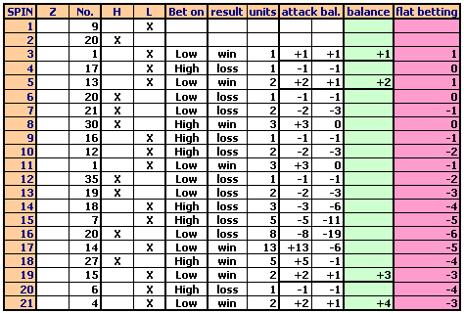
Example 2, from Table No.1, Spielbank Hamburg, 2002-07-04, High & Low (spin 1 - spin 35), betting selection: before last.
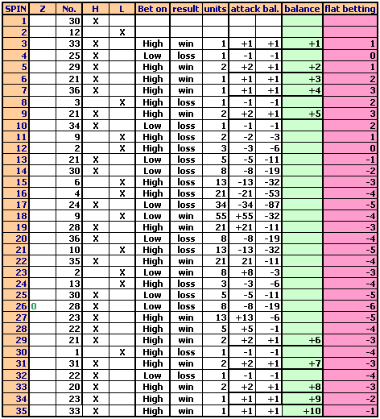
As you can see 2 won bets in a row lead to a remarkable reduction of the deficit. However, this example is a good demonstration not to use the bet on the decision before last. If you encounter long alternates of series of 2, it will be very difficult to recover these kind of losses.
If you lose a bet due to zero /double zero ( as before spin 26), repeat the bet. The amount lost due to the zero appearance has to be subtracted from the session balance.
The Whittaker progression should be used in no case without a good betting selection.
The disadvantage of the Whittaker progression is the fact that the bet size can grow rapidly with several consecutive losses.
A method to slow down the rapid rise of the bet size is to divide the sum of the last 2 lost bets by 2 and continue accordingly.

