THE GUETTING PROGRESSION
As you very well know, a progression in itself never can produce a superiority in general over the wheel, even if it is finely constructed. It can never change a negative expectancy game into a profitable one in the long term. There may be some exceptions necessitating a very high bankroll, but therefore these are not useable for the majority of players.
The Guetting Progression is most effectual in connection with a good tendency march. This progression was developed by the French system player Charles Guetting, who achieved a remarkable fortune during his many years in Monte Carlo.
Charles Guetting played exclusively Trente-et-Quarante, however his progression might as well be applied on even money bets on the roulette.
The Guetting Progression is a four stage gain progression:
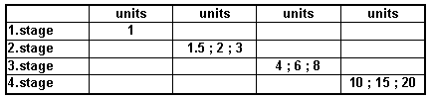
After two consecutive won bets in one stage the progression moves on to the next higher unit bet in that stage:
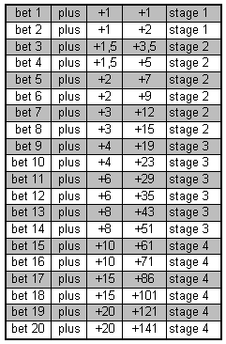
After the loss of a bet, the Guetting Progression steps down to the first unit size in the next lower stage, therefore down to 4, 1.5 or 1, depending, in which stage the bet was lost.
This loss can occur:
1.) if immediately after two consecutive won bets the next higher bet is lost
2.) if 2 consecutive losses appear.
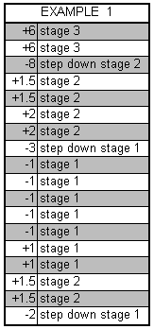
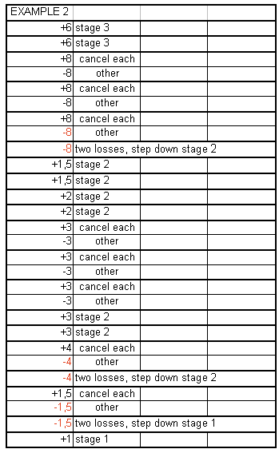
In the next table we will compare flat betting and three well known progressions ( the Martingale, the d´Alembert and the Contra D’Alembert ) with the Guetting Progression:
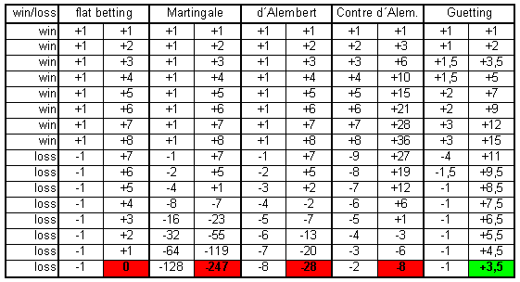
Try for yourself! You will see astonishing results!

