PROGRESSION DEANCE
The well-known Martingale-progression follows an arithmetical row:
1 - 2 - 4 - 8 - 16 - 32 - etc. pp .
This is a double up progression. The danger of the Martingale is the table maximum. After 11 consecutive losses, usually the table maximum has been reached and the Martingale is now unable to recover the previous losses.
The progression Deance is a Multi-martingale,
based on
the principle of cancellation.
Gain target is 4 units!
Objective of the Deance is to win a total of 4 units. These 4 units are considered
a fictive loss and shall be regained.
The 4 units are evenly distributed to 4 columns, as in Table 1.
The first bet is almost the number of units in column 4, the second bet
is the number of units in column 3, etc .
If a bet wins, this bet is cancelled in the appropriate column.
If a 1-unit-bet loses, this unit is entered in the far left empty column
or added to the columns from left to right.
If a 2 or more unit bet loses, the units of this bet are split evenly
and added from left to right to the units of the 4 columns in the next bet line.
By splitting the lost bets and distributing them evenly, the best size rises
more slowly and more than 40 consecutive losses are necessary to bring the
bet size to the table maximum.
Table 1:
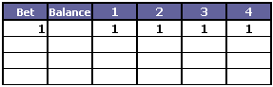 | This is the progression table before the first bet.  The unit from progression column 4 is bet.
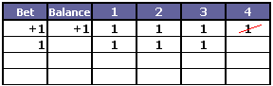 | This is the progression table after the first bet.  The 1 unit from column 4 has won and is cancelled.  Now the remaining 3 1-unit-bets are noted in the next row.
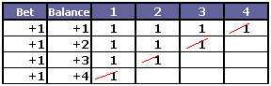 | This is the progression table after  4 consecutive won bets.  Every bet was won and all numbers in the 4 columns  have been cancelled.
Now what happens if a bet is lost?
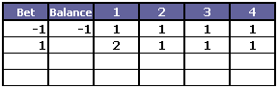 | The first bet from column 4 is lost.  It cannot be cancelled, but still it shall be won back.  Therefore this lost unit is added to the 1 unit in column 1.  Bet size of column 1 is now 2 units.  Next bet is again the 1 unit from column 4.
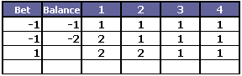 | Again the bet from column 4 is lost.  This lost unit is added to the 1 unit in column 2.  Bet size of columns 1 and 2 are now 2 units.  Next bet is again the 1 unit from column 4.
Table 2:
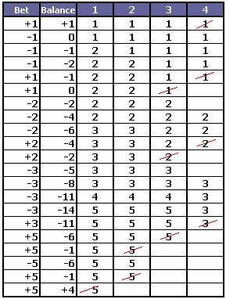 | This is a complete progression-run:  the gain target of 4 units is reached after  11 lost and 10 won bets!
Table 3:
It is possible to stretch the Deance progression further, however this makes
the session longer.
For example:
Target gain 6 units
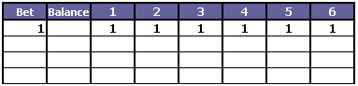
Target gain 8 units
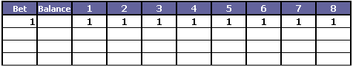

TRY FOR YOURSELF!

